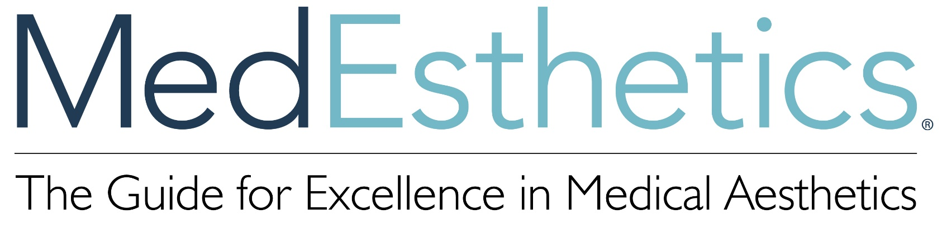

MedEsthetics magazine is partnering with Face & Body Northern California 2022 event.
Our Advanced Education Conference program is now seeking 50-minute product-neutral educational presentations from industry experts. Do you have a great topic that would help medical aesthetic professionals build their skills or advance patient care? Submit it to us by February 25, 2022.

MEDESTHETICS PARTNERING WITH

FACE AND BODY NORTHERN CALIFORNIA 2022

SPEAKER PROPOSAL

Proposal Track:
Challenging aesthetic indications
Beginner and advanced injection techniques
Energy-based devices and skin type
Body contouring

Practice growth and management

Proposal Title
Proposal Marketing Description
Proposal Learning Objectives:
List up to three Learning Objectives in bullet points. Learning Objectives should define the learner’s outcome.
Proposal Methodology
Presenter Name
Presenter Bio

Please save this form and submit to Laura O’Connor at loconnor@allured.com no later than February 25, 2022.

